Treaty of Versailles Mini-Q

How Did the Versailles Treaty Help Cause World War 11?
EV
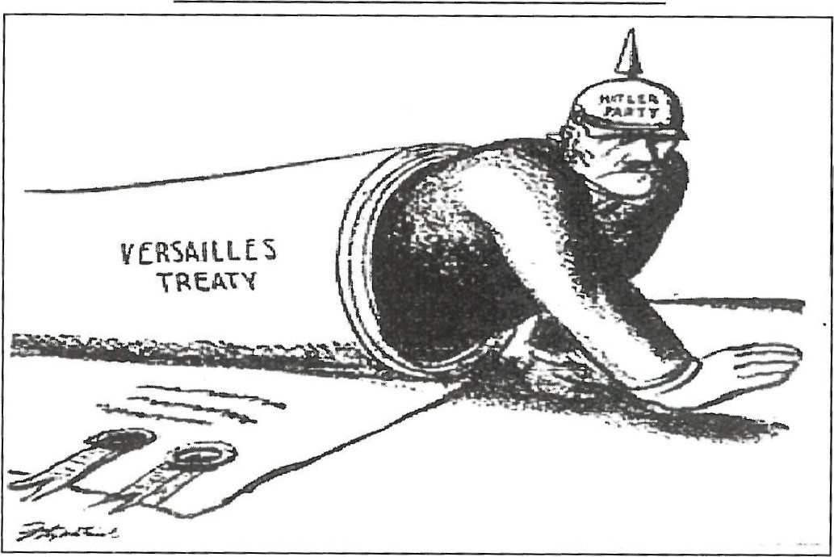
Daniel Fitzpatrick, St. Louis Post-Dispatch, October 19,1930.
Overview: On June 28, 1919 — seven and a half months after the horrific fighting of World War I ended in November 1918 — the Versailles Treaty was signed by the victorious Allied nations of Great Britain, France, and the United States and by a defeated Germany. The framers of the treaty hoped that it would stabilize Europe and ensure that another catastrophic war would never happen again. But just over two decades later, the flames of war consumed Europe. This Mini-Q examines the ways in

which the treaty contributed to the Second World War.
The Documents:
Document A: German Territorial Losses (map)
Document B: Treaty of Versailles, Article 160; Troop Levels, 1920 (cartoon)
Document C: Treaty of Versailles, Articles 232 and 233; Reparations
Document D: Treaty of Versailles, Article 231 ; War Guilt Clause

e

Background Essay
How Did the Versailles Treaty Help Cause World War Il?

It is hard to say anything good about World
War I. Fought mainly in western and eastern Europe, it was a war that took the lives of 10 million soldiers and seven million civilians, and wounded 10 million more. It was a war where men charged one another, again and again, through a storm of machine gun fire and mustard gas only to find themselves, months later, lying in the same God-forsaken trenches they had dug one year before.
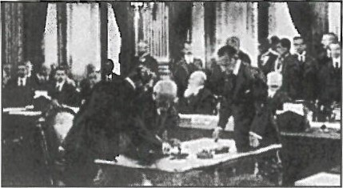
The main combatants in this war included the major nations of Europe — Germany, AustriaHungary, and Turkey on the one side — France, England, Russia, and Italy on the other. The reason for the war was, at bottom, a struggle for economic and political power. It grew out of the scramble for overseas colonies, ethnic and national pride, and a tangle of alliances that said "I'll help you if you help me." It was a war coaxed into being by a huge military build-up. England was determined not be outdone by anyone else's navy; Germany was determined not to be outgunned by anybody else's army. By 1914 a tense Europe bristled with weapons.
An assassination in the Balkans triggered the actual fighting and the devastation followed. In 1917, after three years of indecision, the
United States entered on the side of England and France and it was enough to tip the balance. By the summer of 1918 Germany was ready to give up. Ironically, little if any of the war had been fought on German soil. Most of the carnage had occurred on the Western Front in France and Belgium and on the Eastern Front near and in Russia. The result was that many of the German people, due to the government's control of the press, had not known they were losing. Thinking that the war was no worse than a draw, they would not be prepared for a harsh peace.
The war ended on November Il, 1918. It was only a few months before leaders from around the world would meet at Versailles in France to hammer out a treaty. The major players were Prime Minister Georges Clemenceau of France, Prime Minister David Lloyd George of England, and Woodrow Wilson, President of the United States. Germany was given no voice. Russia, who had pulled out of the war in 1917, was not represented.
Woodrow Wilson wanted the treaty to guarantee independence for many of the national groups in Eastern Europe. He also wanted to create a League of Nations to settle future

DBQ

Background Essay Questions
- What were the years of World War I?
- What were the military and civilian death total in World War I?
- What were three causes of World War I?
- Why were the German people not prepared to accept the harsh peace terms of the Versailles Treaty?
- Who were the three government leaders that shaped the Versailles Treaty?
- What was Germany's role at the Versailles conference?
- How did the goals of Georges Clemenceau and Woodrow Wilson differ?
- What was the concern of English treaty representative George Maynard Keynes?
- Define these terms: mustard gas
combatants
carnage
Western Front
Eastern Front
League of Nations

Timeline
1914— July 28: Austro-Hungarian emperor Franz Joseph declares war on Serbia.
1915 — German sinking of British luxury liner Lusitania kills 1 ,198 people including 128 Americans.
1916— Battle of Verdun. German and French armies fight almost the whole year. One million people on both sides die or are wounded.
1917 — April: United States declares war on Germany.
1917— October—November: Bolshevik Revolution in Russia. Communist rule begins in the newly formed Union of Soviet Socialist Republics.
1919— June 28: Treaty of Versailles is signed by delegates of Germany and Allied Powers.
1932— Unemployment rate in Germany reaches 30%.
1933 — January 30: Adolf Hitler is named Chancellor of Germany.
DBQ

Understanding the Question and Pre-Bucketing

Understanding the Question
- What is the question asked by this Mini-Q?
EV
- What terms in the question need to be defined?
- Rewrite the question in your own words.

Pre-Bucketing
Directions: Using any clues from the Mini-Q question and the document titles on the cover page, think of possible analytical categories and label the buckets.

Document A
Source: German Territorial Losses, Versailles Treaty, 1919. Map created from various sources.
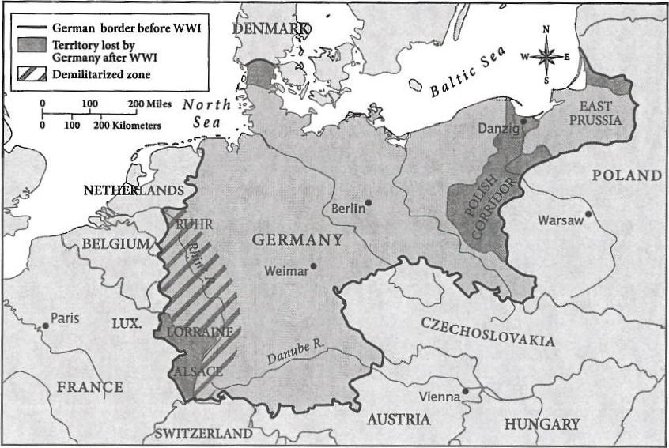
Note: The Treaty took coal-producing areas away from Germany, reducing German coal production by 40%.
Source: Adolf Hitler, Mein Kampf, 1924.
It should scarcely seem questionable to anyone that ... the restoration of the frontiers of 1914 could be achieved only by blood. Only childish and naive minds can lull themselves in the idea that they can bring about a correction of Versailles by wheedling and begging.... No nation can remove this hand from its throat except by the sword.
Note: Adolf Hitler published Mein Kampf ("My Struggle") in 1924, well before he came to power but when he was beginning to make his mark as a German political figure.

Document Analysis
- What territories did Germany lose due to the Versailles Treaty?
- East Prussia remained a part of Germany. Why might the loss of the Polish Corridor and Danzig have been especially difficult for Germans?
- Why might life have been difficult for Germans who lived in the lost territories?
- How does Hitler suggest Germans should respond to the Versailles Treaty?
- How can you use this document to explain how the Versailles Treaty helped cause World War Il?
DBa

Article 160.
By a date which must not be later than March 31, 1920, the German Army must not comprise more than seven divisions of infantry and three divisions of cavalry.... After that date the total number of [military troops]... in... Germany must not exceed one hundred thousand men, including officers.... The Arrny shall be devoted exclusively to the maintenance of order within the territory and to the control of the frontiers.. .. The total effective strength of officers, including the personnel of staffs, whatever their composition, must not exceed four thousand.
Source: German political cartoon, 1920s.
Troop Levels, 1920
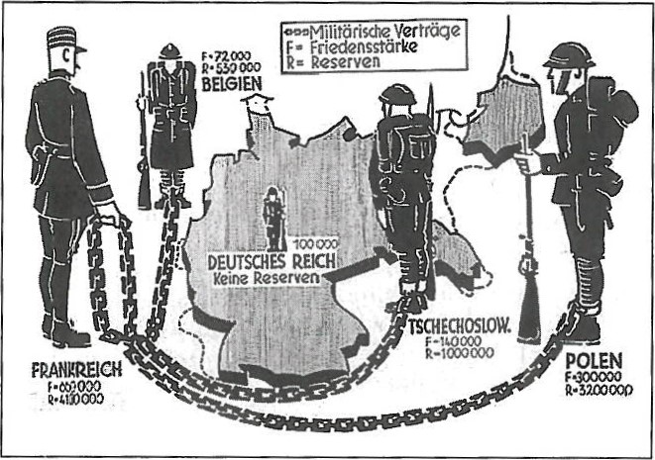
Translations: Frankreich (France)
Belgien (Belgium)
Deutsches Reich (Germany)
Tschechoslow (Czechoslovakia)
Polen (Poland)
Friedensstärke (peacekeepers; full-time military troops)
Reserven (military reserves available when required)
Militärische Verträge (military alliances

Document Analysis
l. What is the total number of German military troops allowed by Article 160 of the Versailles Treaty?
- How does Article 160 define the role of the army?
- Which of the countries in the cartoon image has the largest combined army of reservists and peacekeepers?
- What is implied by the imagery showing the chain held by the large figure representing France? How does this image suggest German politicians and citizens might have felt about their military security compared to that of their neighbors?
- How does this document explain how the Versailles Treaty helped cause World War Il?

C:
Content Notes:
' The initial amount of reparations required of Germany was originally slated to be over twice as much
(269 billion gold marks), but was gradually reduced in 1921 to 132 billion gold marks.
- Despite the enormous economic problems in Germany following World War l, Germany did not have to rebuild bridges, roads, schools, and businesses as did many other nations—particularly France and Belgium—because no major battles of the war were actually fought in Germany.
- Germany paid only a small portion of its reparations payments. Germany received three times as much in loans from the Allies than it paid out. Reparations by themselves did not ruin the German economy, but right-wing parties threatened to overthrow the Weimar Republic for agreeing to them. This made the political situation between the wars very unstable.
- Germany completely repaid its World War I reparations obligations on October 3, 2010, which was also the 20th anniversary of the reunification C
Article 232: The [Allies] . . . require, and Germany undertakes, that she will make compensation for all damage done to the civilian population of the Allied and Associated Powers and to their property during the period of the belligerency....
Article 233: The amount of . . . [reparations or payments] to be made by Germany shall be determined by an Inter-Allied Commission, . [which will] consider the claims and give to [Germany] a just opportunity to be heard.... The Commission shall . . . draw up a schedule of payments prescribing the time and manner for securing and discharging the entire obligations within a period of thirty years from May 1, 1921. If, however . . . Germany fails to [meet] her obligations, any balance remaining unpaid may . . . be postponed for [future payment] or may be handled [in another way that] the Allied and Associated Governments . . . shall determine.
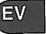
Source: Chart compiled from varied sources including John Maynard Keynes, The Economic Consequences of the Peace, 1920 ; Charles Mee, The End of Order: Versailles, 1919.
Date  1921  1929  1933 | Reparations Established by Versailles freaty with Later Revisions  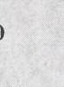  Amount of Reparations Value in 2010 German Response and Payment US Dollars  132 billion gold marks $367 billion to be Anger/humiliation. Paid little in 1920s. paid over 30 years  112 billion gold marks $341 billion Not counting American loans, Germans  (reduced from 1921) pay only 2 billion marks over next three years.  Hitler comes to power, Stops all  reparations payments

Document Analysis
- Why was Germany required to pay reparations for World War I?
- When were the reparation payments set to begin and what was the date by which they were required to be fulfilled?
- In 1929, what was the reduced amount of reparations Germany was required to pay? In German gold marks? In 2010 US dollars?
- What could the Inter-Allied Reparations Commission do in the case that Germany fell behind or failed to make reparations payments?
- How does this document help explain how the Treaty of Versailles contributed to World War Il?
DBQ

D: 231.

Content Notes:

The Allied and Associated Governments affirm and Germany accepts the responsibility of Germany and her allies for causing all the loss and damage to which the Allied and Associated Governments and their nationals have been subjected as a consequence of the war imposed upon them by the aggression of Germany and her allies.
EV
Source: Laurence V. Moyer, Victory Must Be Ours: Germany in the Great War 1914—1918, 1995.
The Allies continued in the years after 1919 to regard the [Versailles] Treaty as an international contract.. .but most Germans saw it as an atrocious injustice, an evil thing which must be destroyed. This feeling persisted long after most of the provisions had been carried out, long after many Germans could even name its provisions. What they knew of the treaty was etched indelibly in their minds and could be abbreviated in [a] single word: humiliation. Nations, as with individuals, do not like to be made to feel disgraced and cast off... It undermines... a sense of worth, their value of themselves... Much of the exaltation [enthusiasm] within Germany arising from the Nazi regime arose [from] the way in which Hitler restored a sense of pride, reawakened a sense of self-respect, forcing the world to look at Germany anew.

Document Analysis
- What is the main idea of Article 231 of the Treaty of Versailles?
- How did most Germans feel about the Treaty of Versailles?
- According to historian Laurence Moyer, why did many Germans admire Adolf Hitler?
- How does this document explain how the Treaty of Versailles helped cause World War Il?
DBQ

Task Two: Thesis Development and Road Map The Chicken Foot
Bucketing — Getting Ready to Write
Bucketing
Look over all the documents and organize them into your final buckets. Write bucket labels under each bucket and place the letters of the documents in the buckets where they belong. You EV can put a document into more than one bucket (multi-bucketing), but you need a good reason for doing so. Remember, your buckets are going to become your body paragraphs.

Thesis Development and Road Map
On the chicken foot below, write your thesis and your road map. Your thesis is always an opinion that answers the Mini-Q question. The road map is created from your bucket labels and lists the topic areas you will examine in order to prove your thesis.
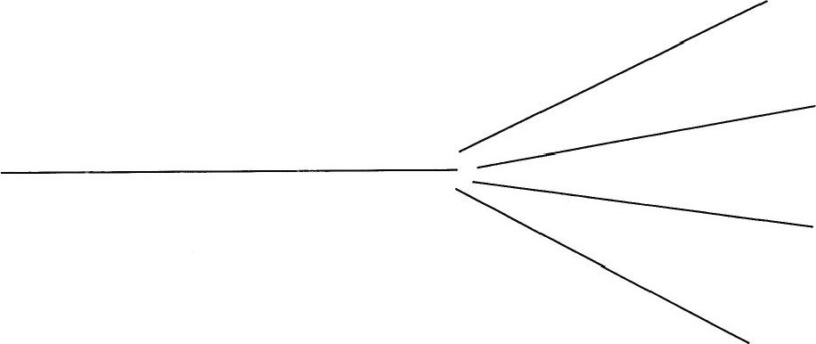
0 OBO
@ DBQ
Student Mini-Q Lined Paper

DBQ
Mini-Q Sample Essay: High Proficiency
0 DBQ

Student Mini-Q Lined Paper

EV

0

